COMPUTER VISION & IMAGE PROCESSING
HISTOGRAM



KHEN MUHAMMAD CAHYO
244107023002
TI-3I
STATE POLYTECHNIC OF MALANG
INFORMATION TECHNOLOGY DEPARTMENT

D1 PRACTICUM – HISTOGRAM
- Create Manual Histogram
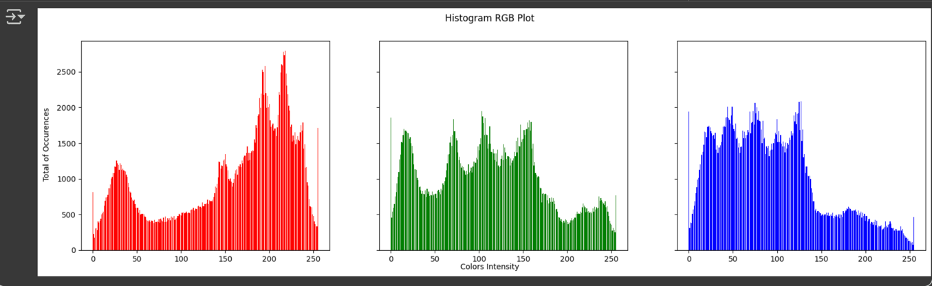
- Number 1 Task – NumPy Histogram
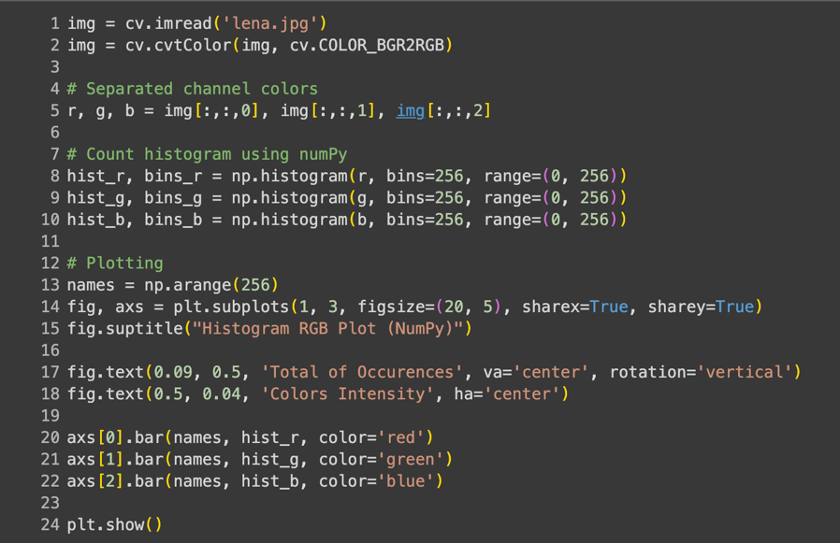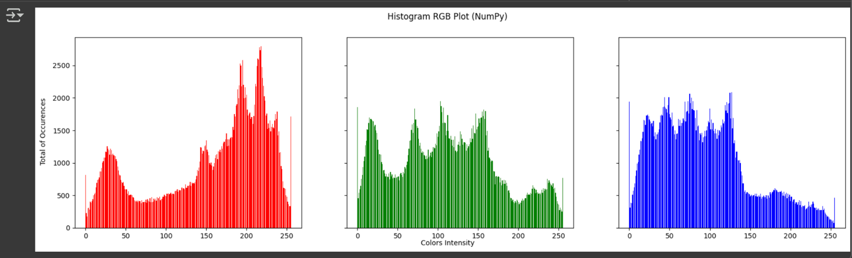
Histograms calculated using manual loops and numpy.histogram produce the same output, as they both calculate the frequency of pixel intensity occurrences within the range 0–255 for each color channel. The only difference lies in the calculation method: manual loops require nested loops for each pixel, while numpy.histogram is more efficient due to library optimization.
- Task Number 2 – KTM Lama
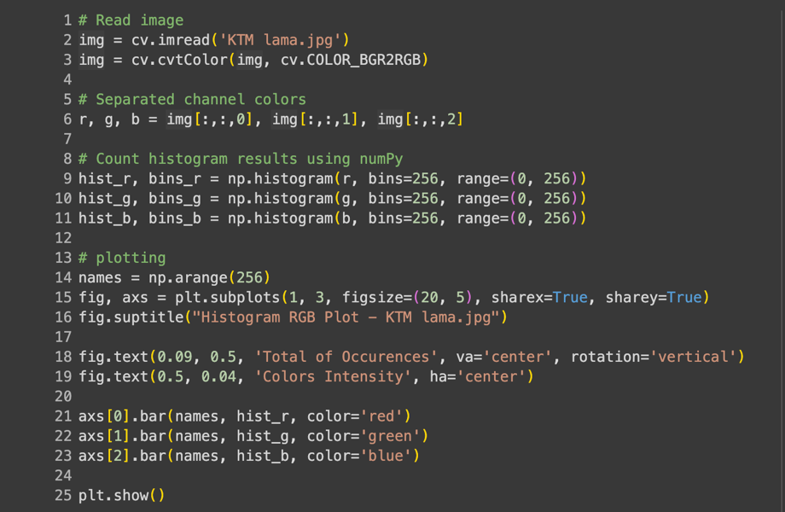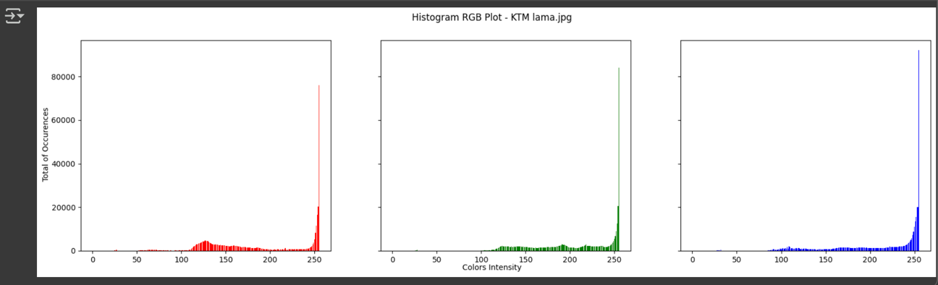
From the histogram of the image KTM lama.jpg it can be seen that the majority of the intensity distribution in the three channels (red, green, and blue) accumulates in the high intensity area (close to 255), while in the low intensity section only a few values ​​appear. This indicates that the image tends to be bright, because most of the pixels are in the very bright/white color range. In addition, the distribution of the histogram is not even across the range (more concentrated at the right end), so this image can also be said to have low contrast, because the variation in color intensity is not evenly distributed from dark to light.

D2 PRACTICUM – EQUALIZATION HISTOGRAM
- Task Number 1 – Compare Equalization Histogram Results
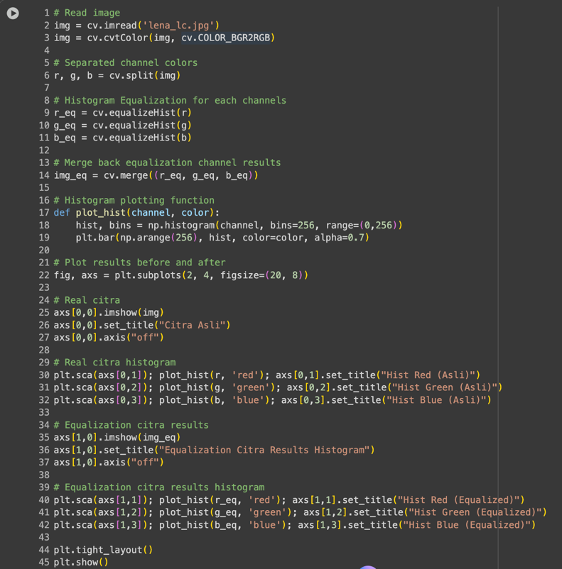
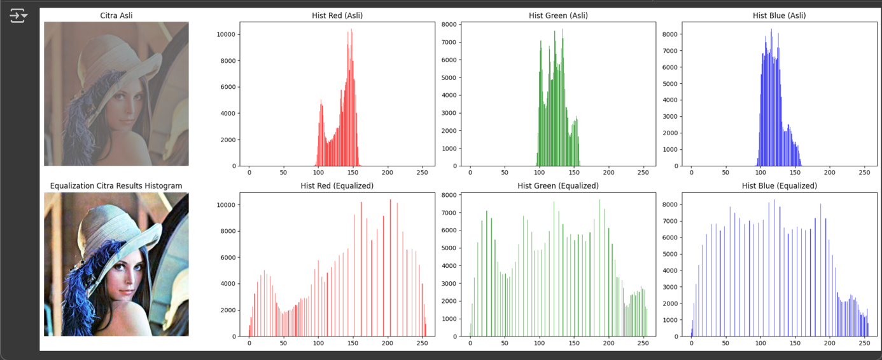

- Task Number 2 – Equalization Histogram CV2
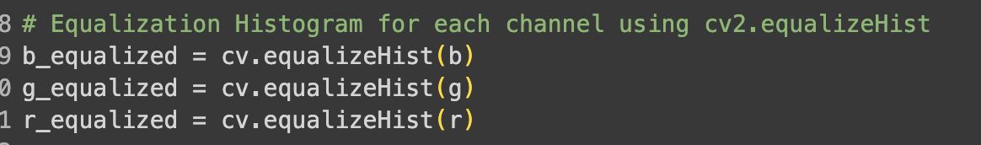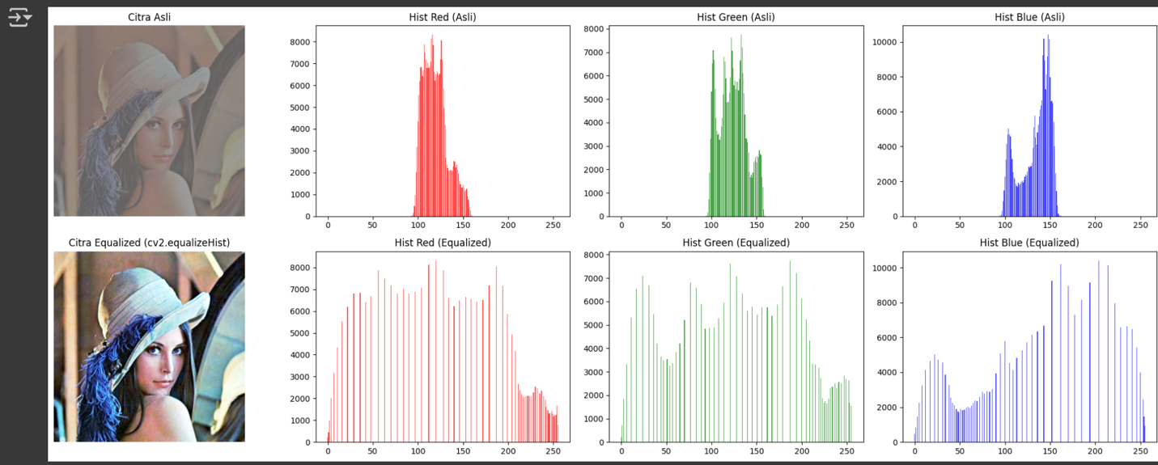
The results of manual histogram equalization (following the previous flowchart) and using cv2.equalizeHist() are essentially the same, as both implement the concept of smoothing the pixel intensity distribution by utilizing the cumulative function of the histogram. The only difference is in the implementation method. Manual > we calculate the frequency, cumulative, normalization, and transformation ourselves. Cv2.equalizeHist > OpenCV already provides a more concise and efficient built-in function.

D2 PRACTICUM QUESTIONS
Number 1 Answers
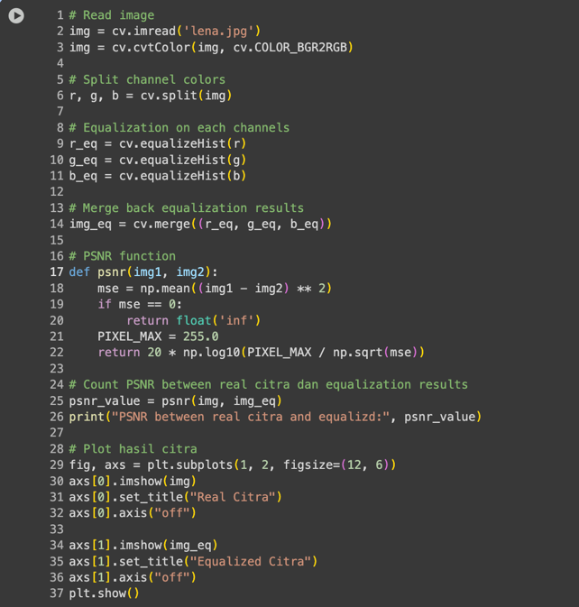
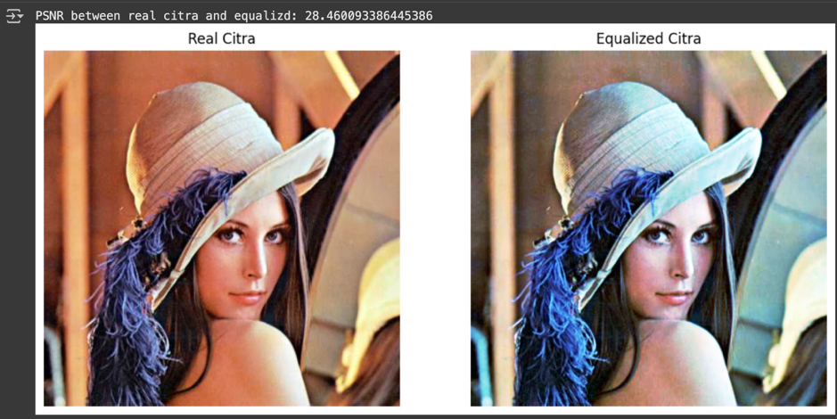
The calculation results show that the PSNR value = 28.46 dB, which is considered moderate (not too high, but not too low). This means that there is a significant difference between the original image and the equalized image, but the visual quality is still well maintained. The main change is seen in the distribution of pixel intensity which has become more even, so that details in dark and light areas are clearer than in the original image. In other words, although mathematically there is a decrease In similarity (PSNR Is not very high), visually the histogram equalization actually improves the readability of Image details and Improves contrast.

Number 2 Answers
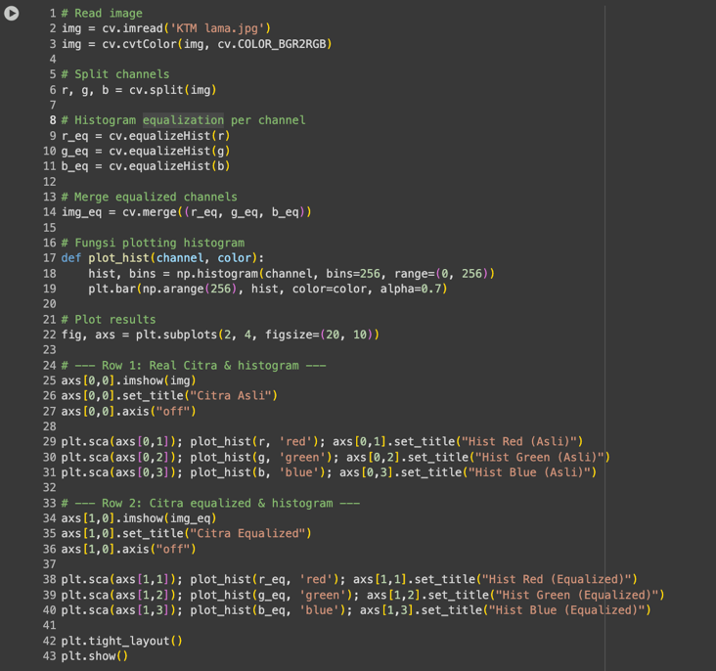
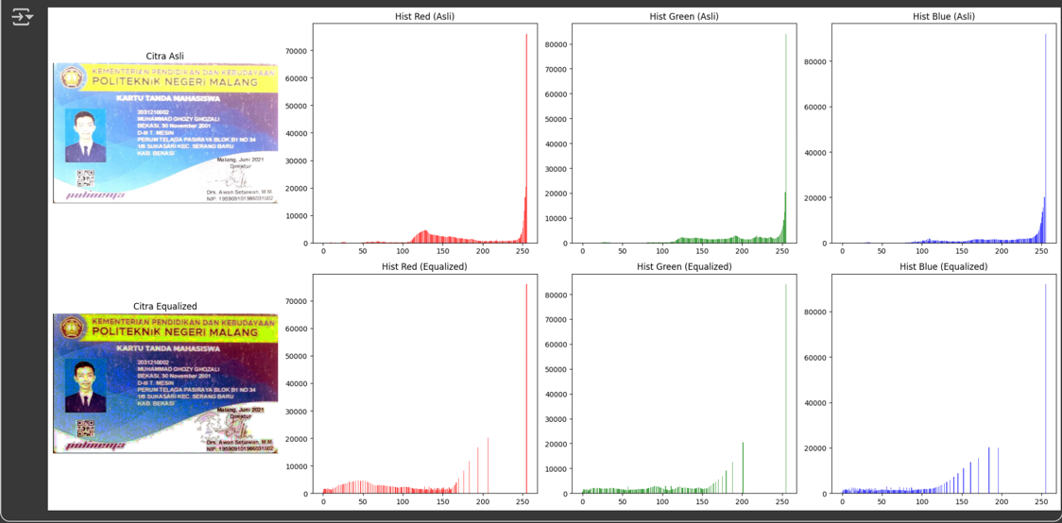
From the comparison of the KTM lama.jpg image before and after histogram equalization, it can be seen that the original image tends to be too bright with a dominance of intensity in high areas (close to white), so that some facial details, text, and background appear less clear. After equalization, the intensity distribution is more even so that details in dark and light areas become more visible, for example facial contours, small writing, and background patterns are more prominent. However, the side effect is that the image looks more “hard” or excessively contrasty, so that the colors look unnatural. In terms of information, equalization does improve the readability of details, but from a visual aesthetic point of view, the results can feel somewhat rough.

D3 PRATICUM TASK – DITHERING
Answer Number 1
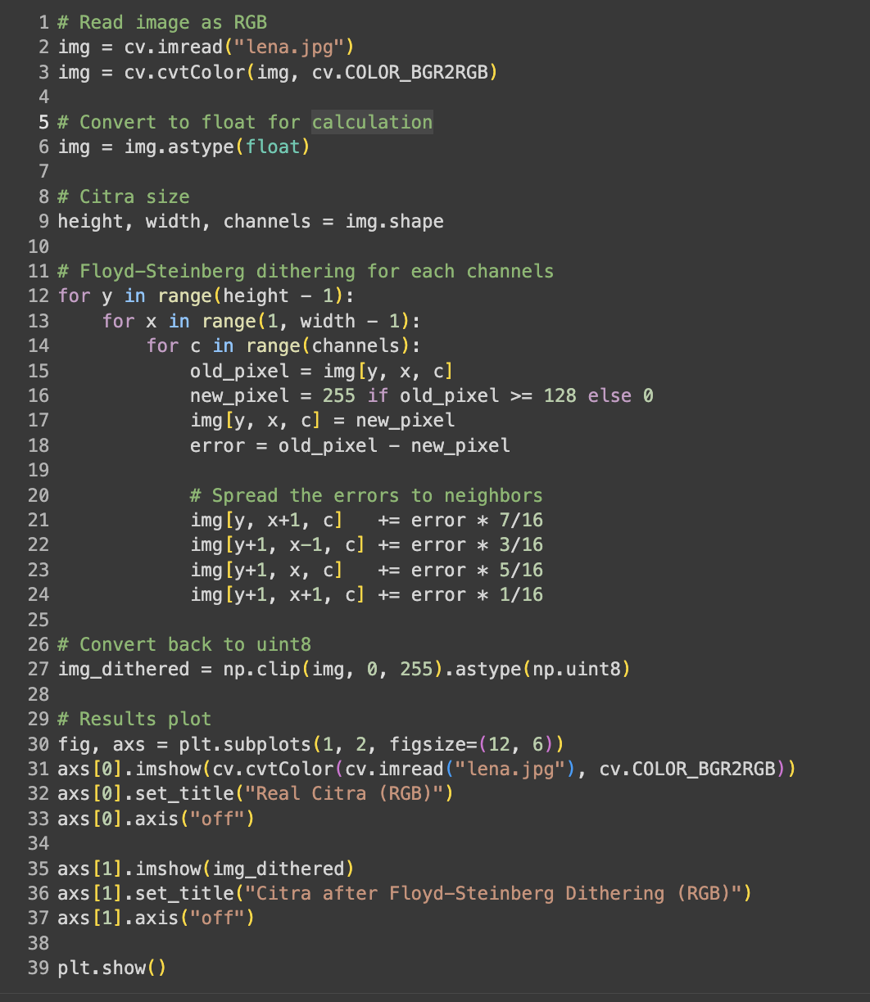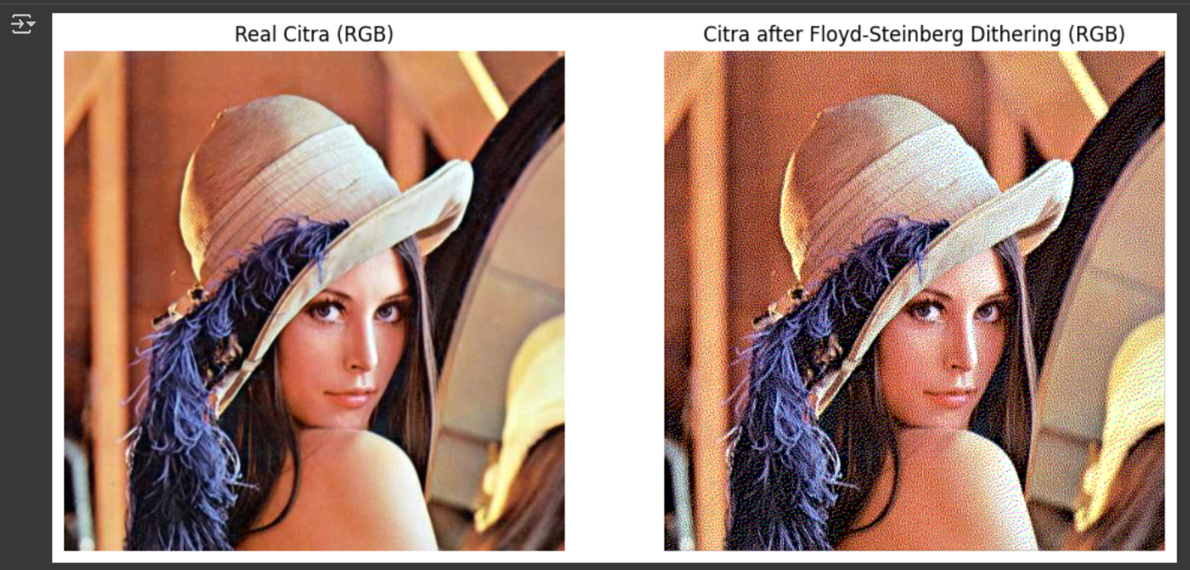

Answer Number 2
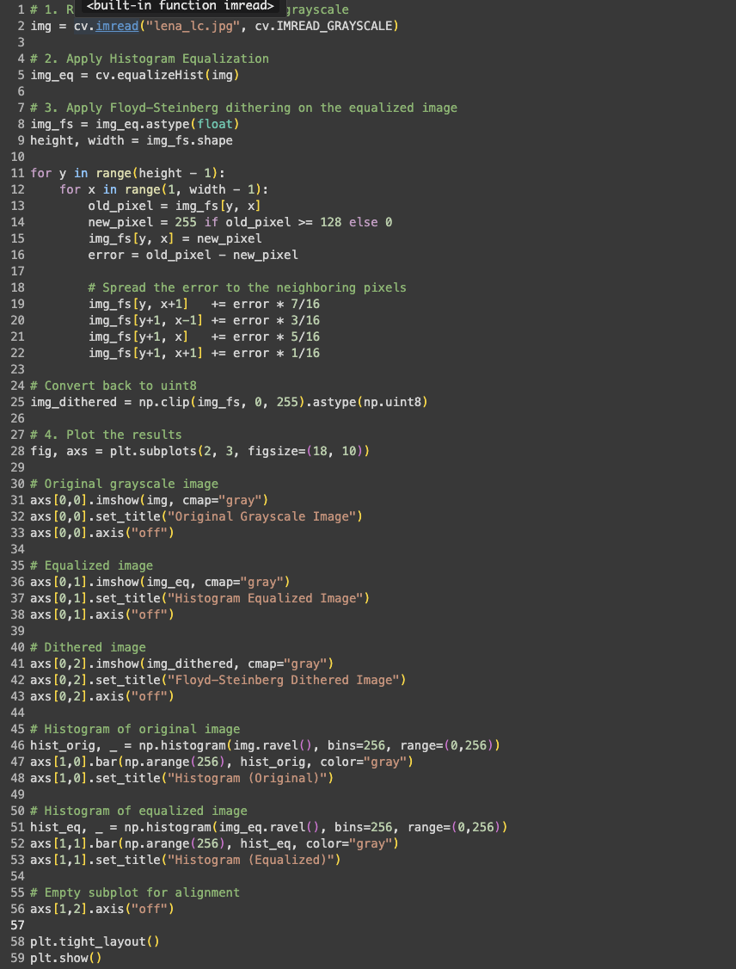
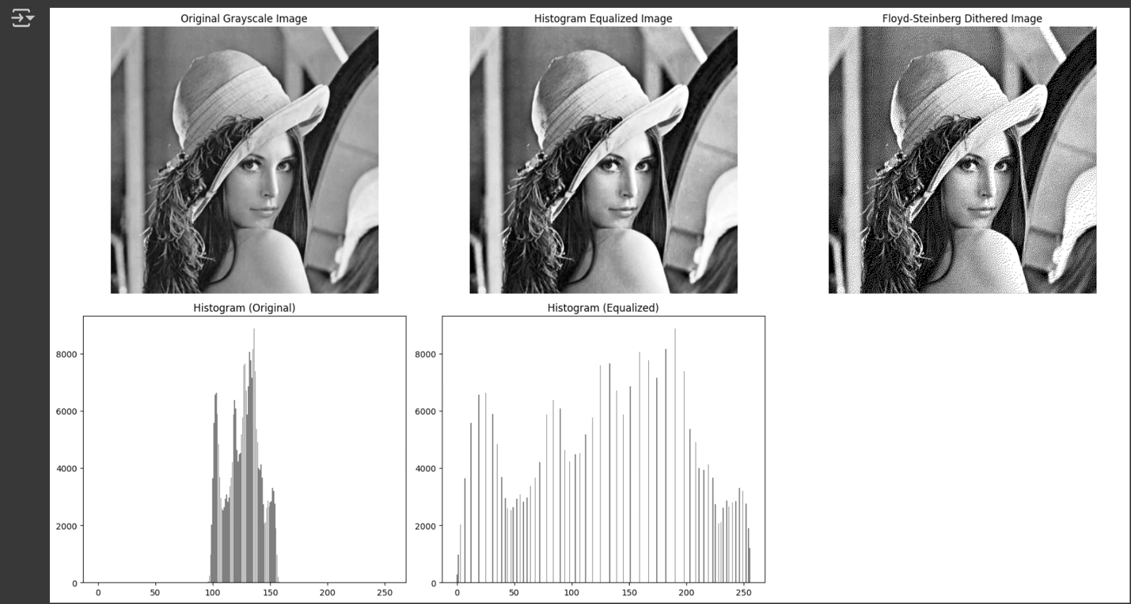

GitHub Link:
https://github.com/KhenCahyo13/MyCampus-Jobsheet/blob/smt-5/pcvk/week-5/Week5.ipynb

